### Two Types of Product Support

What are they? (Define these as best you can)

Customer Support

How do I get started finding a house? How do I find a good roommate? How do I develop a good relationship with my roommates?

Technical Support

Why are my payments not in my account? Why can’t I sign into my account?

What are common technical support questions from web applications? (Check FAQs of other app websites)

* Student side:
  + I can’t sign in to my account
  + Forgot username/password/both
  + Password reset link not working
  + Payment isn’t going through
  + How to clear outstanding payment
  + Have unknown charge
  + Payment options
  + Gift cards/promo codes
  + Refunds (how they work/policy conditions)
  + Not able to contact/use chat properly/there are bugs in the chat feature
  + App is buggy/restarting app doesn’t work
  + ID Verification/Authentication (figured Smarta wld be similar to Airbnb where users need to verify)
* Property Manager side:
  + I can’t sign in to my account
  + Forgot username/password/both
  + Password reset link not working
  + Payment isn’t coming through
  + How to update/revise charges
  + Payment options
  + Refunds
  + Difficulties in Uploading Photos/Properties
  + ID Verification/Authentication

What are common customer support questions from web applications?

* What is Smarta & what’s the purpose/mission?
* Why use Smarta?
* How’s Smarta work (business model, user experience, etc.)?
* What are the essential steps of the housing process?
* How to find a good roommate?
* How do I resolve issues with roommates/property managers?
* How to figure out what types of leases there are/what’s best for me?

Which of these questions do you believe, based on our features and customers, Smarta will be responding to regularly?

* Why use Smarta?
* How’s Smarta work (business model, user experience, etc.)?
* What are the essential steps of the housing process?

What are some applications or programs that assist small support teams? What is the price per month for 1 customer support agent to use them?

* Chatbots
  + Chatbot: $50/month basic plan, $149/month Team plan

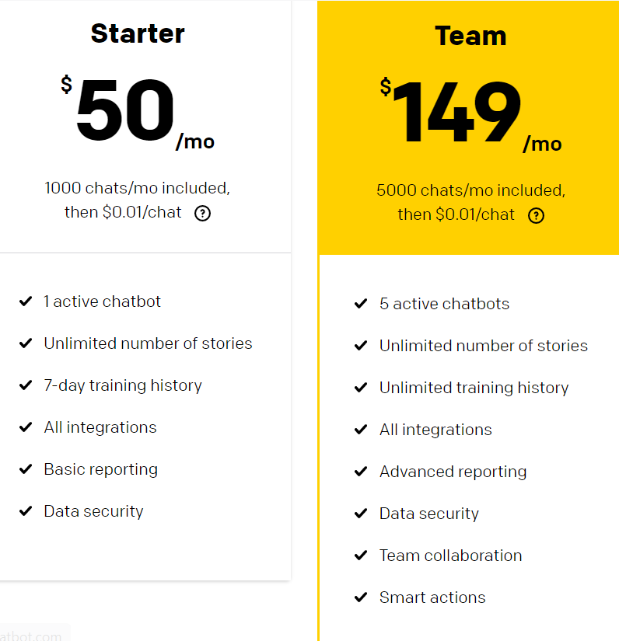

* Master of Code (no pricing plans listed, must contact them), good reviews though!: <https://masterofcode.com/chatbot-development>
* Botscrew (no pricing plans listed, must contact them): <https://botscrew.com/?utm_source=themanifest.com&utm_medium=referral&utm_campaign=artificial-intelligence-chatbot>
* OTR (no pricing plans listed, must contact them): <https://otr.eu/?utm_source=themanifest.com&utm_medium=referral&utm_campaign=artificial-intelligence-chatbot>
* Electronic forms (could be free if it’s just Google forms)

Where are customers turning when they need support with Smarta? (Think “locations”: can they find it on our website? Where? How big or small is it? Is it also in our app? How easily accessible should it be?)

* Website: for common/bigger problems like general housing info or typical account/app issues that wld come with almost any app (VERY accessible)
* Website chatbots: for more niche problems but that users feel don’t need super customized information/responses for (VERY accessible)
* Instagram DMS: more casual/simple questions that can be answered fairly quickly (fairly accessible)
* Contact us email/phone: big/more pressing issues that are more niche/can’t be found or answered anywhere else & would require an actual person on the other end sitting down with user and figuring out how to help/what to do (accessible)

Are there ways to automate our customer support to answer repetitive questions or remedy other efficiency blockers?

* Chatbots
* Consistently update website FAQ & website copy as we identify new questions that are fairly common/reoccurring
* Perhaps using some kind of form submission that users can fill out ahead of time when they have questions they want to contact us with so that we can track users’ more niche/can’t-find-on-website problems & easily analyze patterns that way